Powers and notation

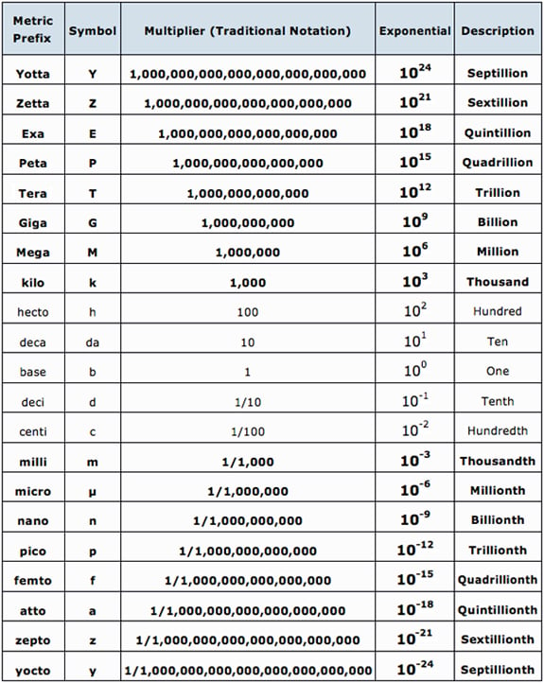

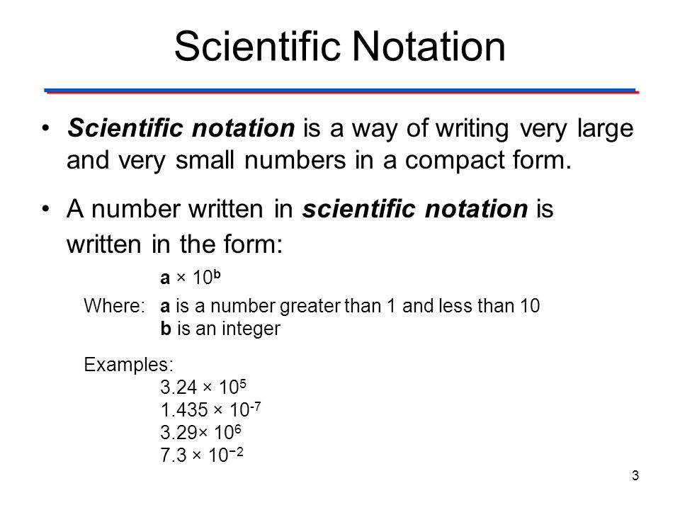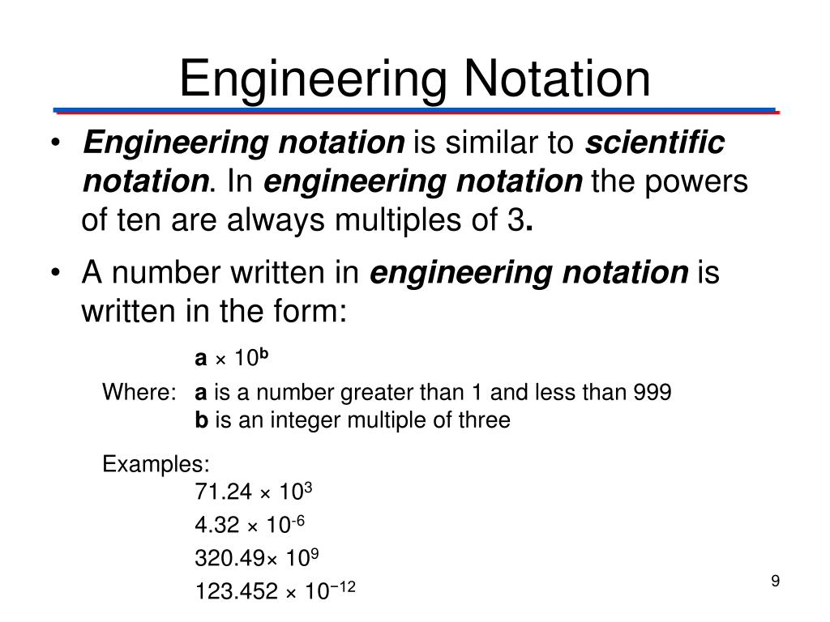

Ohms law

The scientific or mathematical relationship between volt, current & resistance.

Resistance

Resistance is the opposition to current. One ohm is the resistance if 1 ampere is in a material when one volt is applied.

Energy- the ability to do work

Measured in Joules Letter- “W”

Power= the rate at which energy is used- measured in watts- “P”

Watts law

P=VI

P=I^2R

P=V^/R

Magnetism

A force that attracts or repels objects

A magnet is a material or object that produces a magnetic field.

A magnetic field is the lines of force that radiate from north to south through as magnetic material

Magnetism is the force exerted by magnets when they attract or repel each other or other materials.

Magnet- a material or ckt that produces a magnetic field.

2 Types- Natural, man made

Magnetics

Lines of force never cross, contiun loop, cannot be stopped, can go thru most materials.

Magnetic flux

Unit of measure weber

Reluctance: Opposition to the magnetic field

Permeability: ease at which a magnetic field can be established

Electromagnetics

Passes DC

Opposes AC

Passing a current thru a coil will produce a magnetic field.

Define

Voltage

Current

Resistance

Power

Energy

Conductance

Energy – the ability to do work measured in joules letter “w”

Conductance- the ability to conduct current measured in siemens (MHO) letter “G”

AC vs DC

Powers of 10/ powers of 10 math

Resistors types- variable, fixed

Color code

Series circuits cals- I stays same

Paraellel circutis- v stays same

Define magnet types-

1. Perm
2. Electrinc

Passing a current thru a coil creats a magnetic field.

Pass a magnetic thru a coil will produce voltage

What is a relay

What is a solenoid